Austin Frisby
Dr. Bailie
English 2089
10 August 2019
Gaming Discourse
Video games and the gaming industry is very diverse that people outside this industry might not know. Video games are made by a lot of different developers and are designed to be in one or more subcategories of games. There are lot of ways to develop and reasons for developing video games as there are to play them. Some people want to play games casually, for the fantasy, the story, the visuals, and many more reasons. Another way to play video games would be competitively, to try to be the best at a game that they enjoy. Once someone makes that decision they start to play with a consistent group of people where they are all trying the best at a game. It starts to create a group that not only plays together but takes it a step further and they become their own discourse community.
In my case it was a group of friends, who were all fans of the Call of Duty (COD) franchise and decided to take it a step further. We all, the four of us, collectively thought that we were good players and wanted to test our skill. Some of the people in the group watched Youtube videos of people playing COD competitively, the equivalent of amateur matches, and discovered how we could form our own team and find games against other teams that want to play in a more competitive setting. I was around during the start of us getting into competitive but didn’t participate/play with the group until a few months after. Once I joined the group there was a readjusting period because the three of them had already form there own chemistry/discourse and I was new member trying to find my role in the group.
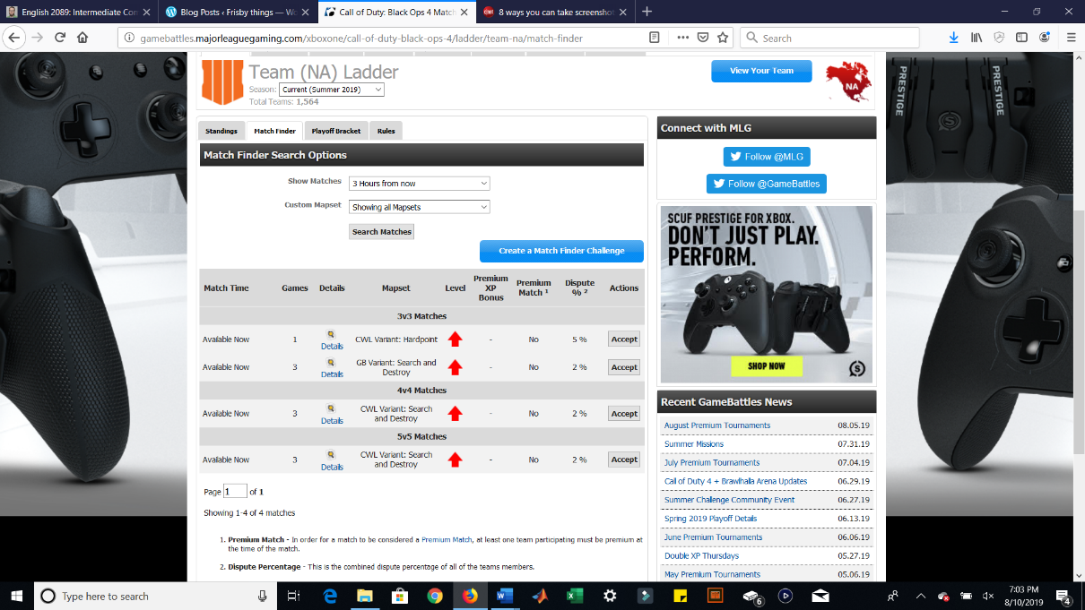
The discourse of the group had already been established once I joined but what shaped it was by another discourse community. To get into competitive gaming for COD, since only a few games in the franchise offered a ranked playlist, you would need to go through a reliable third-party website to find games and to ensure fairness during matches. For us we used a website gamebattles.majorleaguegaming.com to fulfill this role. This website offers an automatic way to keep simple statistics, like win loss record, and a way to ensure the fairness by disputing results if you found that the other team was cheating. A little on how the site works is that you can find or post a game with the rules and gamemode that you want. Once a game is found the website give both teams information about the other a way to invite/communicate with them in game. Then after the game is played both teams have to manually enter the results of the match and then it shows up in the teams win loss ratio.
How is this site a discourse community? The main goal of the site is to provide a way to find games between other teams and they want them to be fair too. One way they work to ensure fairness is that it gives teams an indication on how good another team might be. This indication is based on your teams rank on the ladder and it gives an up arrow for a team that is significantly higher on the ladder and a down arrow for a team significantly lower on the ladder compared to your team. This site also has a committee with different members of the gaming community that rules on any disputes teams may have to ensure that the rules were followed and if not correct the results of that match. Another feature this site has, its more annoying than helpful, is that it sends you an email whenever your team finds a game. It is a way to communicate to every member that is supposed to be in that game a chance to be notified if their own team fails to do so. The site also sends out an email to the person who submitted a claim on a dispute based on how the committee rules on it (most of the time teams already know how the committee will rule if they have the proof so this is more on the annoying side).
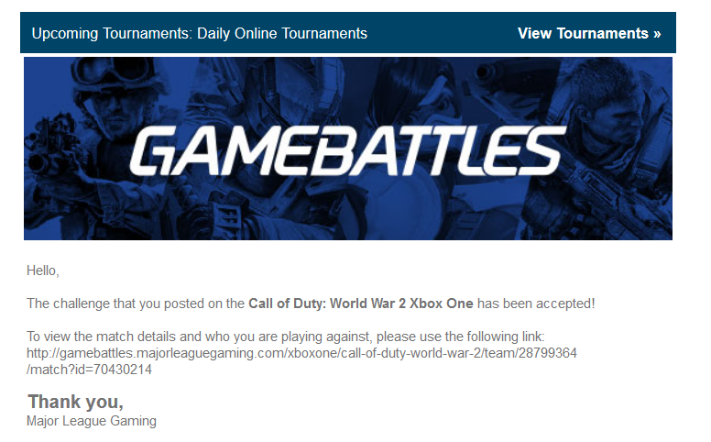
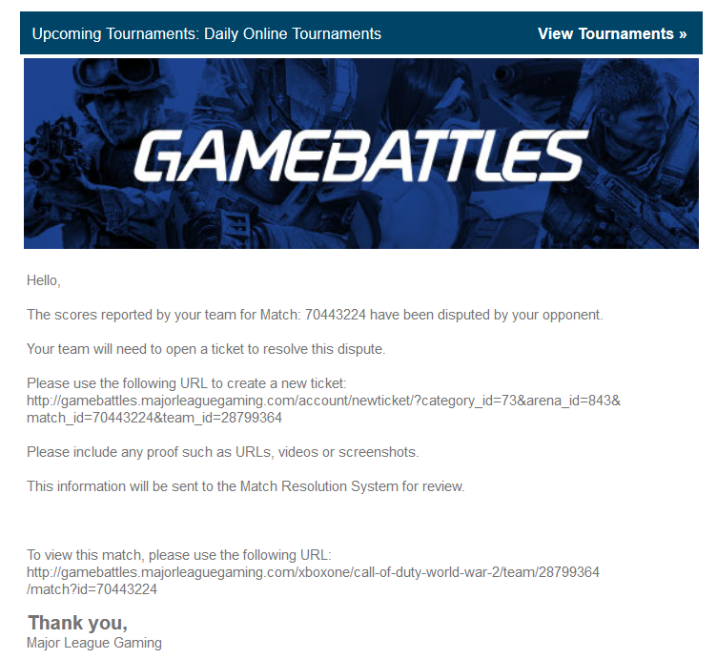

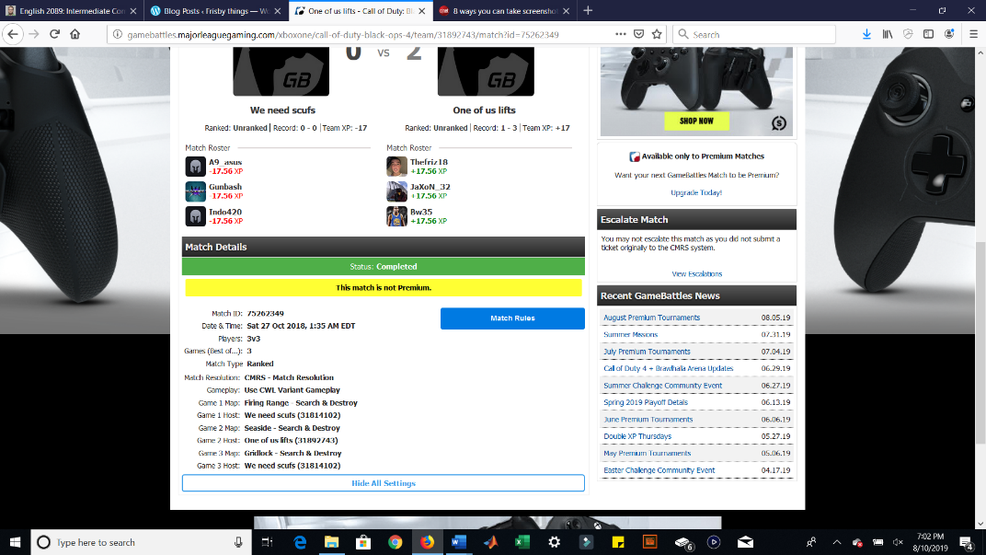
This site does have some specific terminology that it uses. As mention earlier “ladder” is referring to a league. Ladders vary based on region and team size. It’s a way to see where you rank compared to other teams of that size and in your region. Some other terminology would be “gamebattles(gb) variant”, “CWL Variant”, and “MLG rank”. For gamebattles variant it is a pre-made set of rules for different gamemodes that the site provides. CWL variant is also a pre-made set of rules for gamemodes but that are the same rules that COD professional players play with in tournaments. Most of the time gb variant and CWL variant were very similar but with a few tweaks made by the site. MLG ranking refers to your own personal rank and how your total win loss ratio compares to other members on the site. The website has other video games on there to find competitive matches for, not just COD, and all that gets taken into account to determine your rank. To join you had to have an email and be able to link your xbox live account or PSN account to your profile. The site had a system in place to kind of police the members on the site and this was done by the committee. If a person or team disputes a lot of games, were they say they win but actually lost, and they don’t provide proof of them winning then they get suspended from the site and after multiple repeated uses actually banned from the site. This also plays into the different level of experience between members of the site, when we first started out the more experience teams would do that to us if we beat them and early on we didn’t know how important it was to obtain proof of a win so those teams would take advantage of us to boost their record.
Coming back to the team that I was, kind of still am, apart of that we formed a discourse community between us. Our goal was to be the best that we possible could be and later that evolved into trying to win every game we play. Early on we discovered that we actually sucked at COD when it comes to the competitive scene, so our goal quickly became getting better and developing good chemistry/teamwork. I stopped shortly after and when I came back, they had won a couple of games and had adapted to the play style required for competitive, but they had a significant losing record on the team. The goal changed from just getting better to win a game occasionally. After a year and a new COD game came out the goal became to try to win every game. The group had a text group chat where we let each other know when we were getting on or send information about a strategy they came across. During our first year we would talk to each other through xbox live chat to communicate with each other in game. As a group we developed some of our own terminology. Most of them were map callouts which are places we gave a name to on the map to let other members know if an enemy was spotted there or other important information. One specific callout location was “top boat”, the map was a ship, referring to the upper level of the ship and there were two sides so to distinguish we based it off our spawn location for that round. The specified version would be “top our boat” or “top their boat”. Another phrase we used was “right off the RIP” referring to the beginning of the round. Later on, we developed more terminology like “garden” which refers to points gathered from non-killing actions. It was used in a way to say that if someone had a lot of these points that they weren’t doing anything even though those actions were important. There was a very steep barrier to join the group. To join you had to be good at the COD, committed to playing, and be available to play somewhat frequently. Then to stay there had to be good team chemistry and being able to find a role that fit with our team. A few people did try to join our team, but it never stuck. One person was good but wasn’t around enough to play and could never find a role for them. The other wanted to play with us but was never serious about joining. Later on it got harder for people to join us since we had so much experience together with terminology and knowing what each member was going to do that other people struggled to fit in.
Being apart of this gaming group meant a lot to me. I was friends with everyone in the group before but after it strengthened my friendship with them to the point where we lived in the same apartment. It had also made me realize how much gaming competitively means to me. When I first started out, I was gaming casually and more into single player rpgs. While I still look for these single player games, I found that I like trying to be really good at online multiplayer games and that kind of directed me to what I play today. Our group did kind of disband halfway through our second generation of COD, life happened and COD not being what it once was along with many other factors, we still game together just not in a very competitive environment. It is a discourse community that is on its last legs and like every year there is going to be a new COD this year. Who knows this could be the resurgence of the group with the false hope that this years COD will be better and be everything we want but until that day comes its looking like the end.

Works Cited
“The World Leader in Online Video Game Competition.” GameBattles, gamebattles.majorleaguegaming.com/.

